1.新建插件项目→GUI From →Jpane;

2.修改继承类改为：AbstractRendering

3.保证该类中有4个方法：

    3.1.load();

    3.2.save();

    3.3.init();

    3.4.构造函数;

4.新建包com.teamcenter.rac.stylesheet和stylesheet_user.properties文件

stylesheet_user.properties文件中：

            T2_ProcessOrdOPRevisionMaster.FORMJAVARENDERING =

com.kostech.processOrderTemplate.P216ProcessOrderOPRevisionMasterForm

5.在文件MANIFEST.MF运行时节点中添加Stylesheet的包名和新增的Java类的包名如下图：

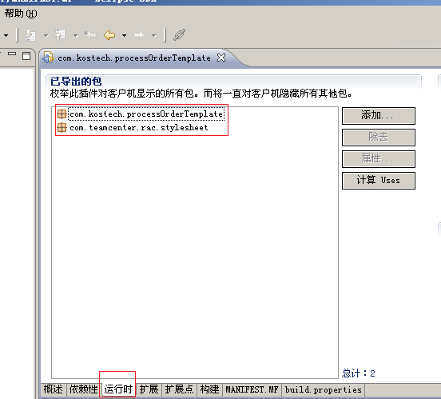

6.代码事例：

P216ProcessOrderOPRevisionMasterForm.java

**package** com.kostech.processOrderTemplate;

**import** javax.swing.JLabel;

**import** javax.swing.JPanel;

**import** javax.swing.JTabbedPane;

**import** com.teamcenter.rac.kernel.TCComponentForm;

**import** com.teamcenter.rac.kernel.TCException;

**import** com.teamcenter.rac.kernel.TCProperty;

**import** com.teamcenter.rac.kernel.TCSession;

**import** com.teamcenter.rac.stylesheet.AbstractRendering;

**public** **class** P216ProcessOrderOPRevisionMasterForm **extends** AbstractRendering

{

//使用jigloo画页面时自动添加

**private** JTabbedPane jTabbedPane1;

**private** JPanel jPanel1;

**private** JLabel labgongxuNum ;

**private** JLabel labshebeiNum ;

//中间变量

**private** TCProperty gongxuNum;

**private** TCProperty shebeiNum;

//定义窗体及会话

**private** TCComponentForm thisForm; //Form

**private** TCSession thisSession;

**public** P216ProcessOrderOPRevisionMasterForm(TCComponentForm theForm) **throws** Exception

{

**super**(theForm);

thisForm=theForm;

thisSession=theForm.getSession();

loadRendering();

}

**public** **void** loadRendering() **throws** TCException

{

initializeUI();

gongxuNum=thisForm.getTCProperty("t2_gongxuNum");//在BMIDE中定义的属性名称

shebeiNum=thisForm.getTCProperty("t2_shebeiNum");//在BMIDE中定义的属性名称

}

**public** **void** saveRendering()

{

gongxuNum.setStringValueData("");

shebeiNum.setStringValueData("");

TCProperty [] ps=**new** TCProperty[2];

ps[0]=gongxuNum;

ps[1]=shebeiNum;

//将TCProperty数组类型属性添加到当前Form中

**try** {

thisForm.setTCProperties(ps);

} **catch** (TCException e) {

// **TODO** Auto-generated catch block

e.printStackTrace();

}

}

**private** **void** initializeUI()

{

//代码画界面时自动生成，不必自己写。

}

}