**User Certification**

The Global Certification Program provides consistent global certification testing in the use and implementation of Siemens PLM Software products by our customers. The main goal of the program is to improve our customers' use of our products and thereby improve their return on their investment in Siemens PLM Software technology. Also, certification allows employers to develop more effective personal development programs for existing employees, quantify the effectiveness of training investments and more effectively screen potential employees and contractors to make more educated hiring decisions.

# [NX Designer Certified Professional](http://training.industrysoftware.automation.siemens.com/certification/designercert.cfm)

NX Designer Certified Professional is one of the important achievements that can be added to your (or your employees') credentials. This program has been designed and structured similarly to professional certification programs in other industries that are in place to validate a user's professional qualifications.

### Certification sessions

The NX Designer Certified Professional examination is conducted in half-day sessions, usually at one of our training centers. During the certification session, you will be required to perform various design related tasks in NX within a set time period.

For more information:

* [Certification Description](http://training.industrysoftware.automation.siemens.com/courses/iltdescription.cfm?c=tr18010)
* Top of Form



* Bottom of Form

### NX

## Designer Certified Professional (NX)

* course code TR18010
* software / version NX 8.5
* user level Intermediate
* price $515
* duration 1/2 Day
* In response to customer demand, Siemens PLM Software developed a certification program for NX professionals. This program has been designed and structured similar to professional certification programs in other industries that are in place to validate a user's professional qualifications. **NX Designer Certification** consists of three timed sections to measure an individual's understanding and application of NX design: 2 skill based sections and 1 knowledge based section
* In **Skill Based Sections**, a test booklet is made available to the test taker. Tasks are completed by opening part and assembly files and then following the instructions for each task. The test taker then answers questions in regards to the task performed.
* **Knowledge Base** sections are an online web based test. It consists of theory questions. The test consist of Multiple Choice, All That Apply, and some True/False questions. At the end of the section, the test takers submits their answers. During the Knowledge Based section, the NX application is not available.
* As part of the NX Designer Certification program, Siemens PLM Software has developed an online assessment tool that is valid for all licensed NX users. This tool will help you evaluate your skills prior to the NX Designer Certification. Visit our [Learning Advantage web site for your free assessment](http://training.industrysoftware.automation.siemens.com/mytraining/login.cfm).

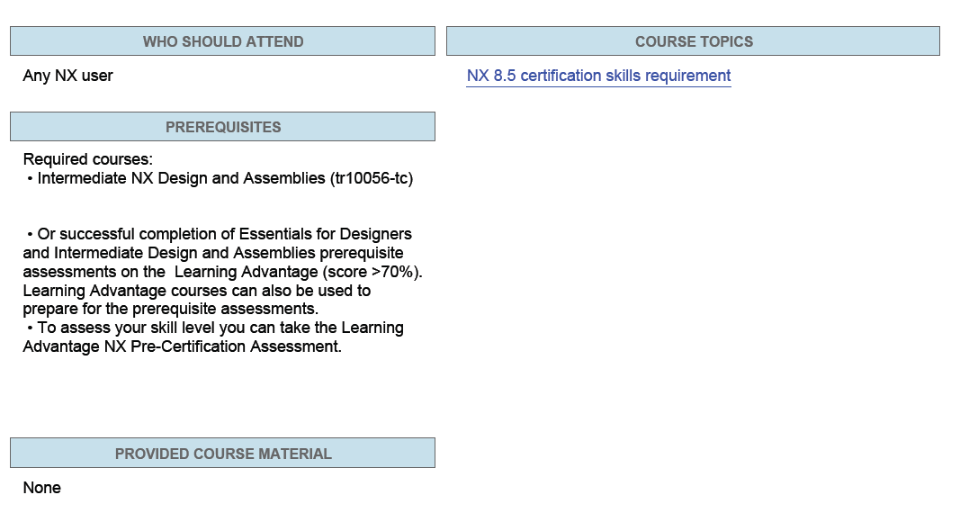

# NX Designer Certification FAQ

### What is the NX Designer Certified Professional certification?

* NX 5, NX 6 and NX 7.5: Designer Certified Professional certification is a hands-on and knowledge based measurement of an individual's understanding and application of NX design
* Pre-NX 5: Designer Certified Professional certification is a hands-on measurement of an individual's understanding and application of NX design

### What are the benefits of Design Certification?

* To the professional it means...
  + Establishes hands-on proof that you have the skills and breadth of knowledge to use NX in mechanical design
  + Formally documents your NX qualifications
  + Increases your worth to your company
  + Facilitates career development and advancement
  + Useful for matching your skills to your job responsibilities
* To the company it means...
  + Increases the proficiency of your employees to help boost productivity
  + Identifies user proficiency levels
  + Aids in screening potential employees and contracts
  + Quantifies the effectiveness of your training investment
  + Facilitates effective use of technical employees
  + Contributes to an employee's personal development program

### What should I expect during the certification examination?

* There will be three timed sections. The entire certification will take approximately 4.5 hours. Online documentation will be available for the skill based sections but one must be careful not to waste too much of their time using it. There is approximately a half hour of orientation information before the examination begins.

### What skills are tested?

* See the [Skill Requirements web page](http://training.industrysoftware.automation.siemens.com/certification/cert_skills_nx85.cfm) for a list of the functionality that may be tested.

### How will the certification examination be graded?

* An automatic grading program will be used. This program provides consistency as well as removes subjectivity of the grader

### What percentage of answers need to be answered correctly in order to pass the test?

* 70%

### What option do I have if I do not pass the test? Can it be retaken? In what time period? Will the retest be the same test?

* The test can be retaken. Since the certification fee will have to be paid again, there is no time constraint on the test taker. The same test will not be given the second time

### What can I do to prepare?

* As part of the NX Designer Certified Professional program, Siemens PLM Software developed an online pre-certification assessment tool that can be found on the [Learning Advantage web site](http://training.industrysoftware.automation.siemens.com/mytraining/sp_list.cfm) under assessments. There is no charge for this pre-certification assessment. This tool will help you evaluate your skills prior to the NX Designer Certified Professional examination

### Are the questions on the assessment test the same as on the certification test?

* No, however they deal with the same functionality

### Are they similar?

* What is similar to you may be very different to me. What I would say is that the assessment tool deals with knowledge base (memory) and skills base task. By working with the assessment tool, the user should be able to establish whether or not they are ready to take the certification test

### Is the certification for a certain version of NX?

* The NX Designer Certification is available in NX 8.5 and NX 7.5.

### How does this tie into the Masters Certificate Program?

* If you completed the courses of the Design Master Training Program and gained experience by developing the skills you were taught in those classes, you should have the expertise necessary to successfully complete the Designer Certification. Completing the Master Training Certificate program shows you have taken the correct classes - NX Designer Certified Professional certification proves you have the skills

# NX Designer Certification Skill Requirements (NX 8.5)

1. Modeling
   1. Coordinate Systems
      1. Absolute CSYS
      2. WCS
         1. Orienting
         2. Moving
         3. Rotating
   2. Reference Features
      1. Datum Planes
      2. Datum Axis
   3. Curve Creation
   4. Offset Curves (associative)
   5. Swept Features
      1. Extruded Body
      2. Revolved Body
      3. Sweep Along Guide
   6. Design Features
      1. Types
         1. Hole
            1. Locating in a sketch environment
         2. Hole Types
      2. Positioning Dimensions
   7. Trim Body/Split Body
   8. Expressions
      1. Create
      2. Edit
      3. Comments in expressions
      4. Conditional expressions
      5. Geometric expressions
      6. Renaming expressions
   9. Feature Operation
      1. Shell
      2. Edge blend
         1. Constant
         2. Variable
         3. Set Back
         4. Edit
      3. Chamfer
         1. Single offset
         2. Double offset
         3. Offset angle
      4. Offset Face
      5. Draft
         1. From Plane or Surface
         2. From Edges
         3. Tangent to Faces
         4. Parting Face
   10. Tools
       1. Model naviagator
       2. Layer category
   11. Edit Features
       1. Edit parameters
       2. Suppress/unsuppress
       3. Delete a feature
       4. Reorder
       5. Suppression by expression
   12. Boolean Operations
       1. Unite
       2. Subtract
       3. Intersect
   13. Duplicating Features
       1. Instance arrays
          1. Rectangular require move/reorient of WCS
          2. Circular
          3. Mirror body
          4. Mirror feature
       2. Copy/paste feature
2. Sketching
   1. Creation
      1. Placement planes
   2. Constraining
      1. Geometric
      2. Dimensional
      3. Evaluate an overconstrained sketch
   3. Positioning the sketch
   4. Alternate solution
   5. Adding curves to a sketch
   6. Move a sketch to another layer
   7. Repositioning a sketch
   8. Pattern Curve
3. Assemblies
   1. Bottom up design
   2. Top down design
   3. Interpart expressions
   4. Interpart modeling
      1. WAVE geometry linker
   5. Assembly load options
   6. Assembly navigator
   7. Assembly clearance analysis
   8. Positioning constraints
   9. Reposition components
   10. Component arrays
       1. Linear
       2. Circular
   11. Reference Sets
       1. Creation
       2. Replacing reference sets in an assembly