**User Certification**

The Global Certification Program provides consistent global certification testing in the use and implementation of Siemens PLM Software products by our customers. The main goal of the program is to improve our customers' use of our products and thereby improve their return on their investment in Siemens PLM Software technology. Also, certification allows employers to develop more effective personal development programs for existing employees, quantify the effectiveness of training investments and more effectively screen potential employees and contractors to make more educated hiring decisions.

**Teamcenter Certification**

The Teamcenter certification is a measurement of an individual's basic understanding and application of Teamcenter in the areas of Usage, Installation and Administration. The certification will be executed online and can be taken in most Siemens PLM Software facilities where a Siemens employee will act as proctor.

The Teamcenter certification is a measurement of an individual's basic understanding and application of Teamcenter in the areas of Usage, Installation and Administration.

### Certification sessions

The certification will be executed online and can be taken in most Siemens PLM Software facilities where a Siemens employee will act as proctor. The Teamcenter Certification is conducted in half-day sessions.

For more information:

[Certification Description](http://training.industrysoftware.automation.siemens.com/courses/iltdescription.cfm?c=tr18070)

Bottom of Form

### Teamcenter

## Teamcenter Certification

course code TR18070

software / version Teamcenter 10.1

user level Intermediate

price $515

duration 1/2 Day

The Teamcenter certification is a measurement of an individual's basic understanding and application of Teamcenter in the areas of Usage, Installation and Administration.

The certification will be executed online and can be taken from any Siemens facility where a Siemens employee will act as proctor.

As part of the Teamcenter Certification program, Siemens PLM Software has developed an online assessment tool that is valid for all licensed Teamcenter users. This tool will help you evaluate your skills prior to the Teamcenter Certification. Visit our [Learning Advantage web](http://siemens.com/plm/LearningAdvantage) site for your free assessment.

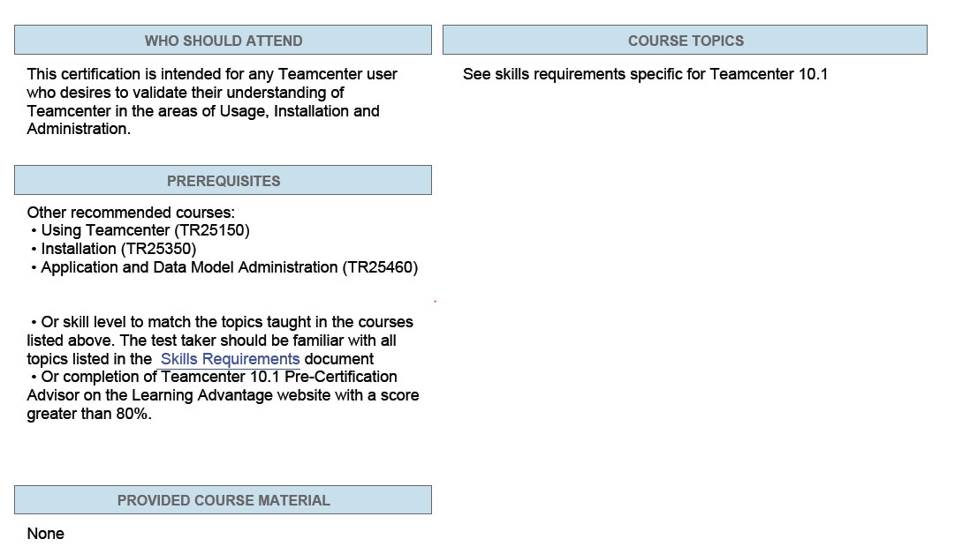

[Certification FAQ](http://training.industrysoftware.automation.siemens.com/certification/faq18070.cfm)

# Teamcenter Certification FAQ

### What is Teamcenter certification?

* Teamcenter Certification is a measurement of an individual's basic understanding and application of Teamcenter in the areas of Usage, Installation and Administration.

### What are the benefits of Teamcenter Certification?

To the professional it means...

* + Establishes proof that you have the basic skills and knowledge to use Teamcenter in preparation for a production environment
  + Formally documents your Teamcenter qualifications
  + Increases your worth to your company
  + Facilitates career development and advancement
  + Useful for matching your skills to your job responsibilities

To the company it means...

* + Increases the proficiency of your employees to help boost productivity
  + Identifies basic Teamcenter proficiency levels
  + Aids in screening potential employees and contracts
  + Quantifies the effectiveness of your training investment
  + Facilitates effective use of technical employees
  + Contributes to an employee's personal development program

### What should I expect during the certification examination?

* + There will be four sections to the test, all about 35 minutes long.
  + The test will be executed online
  + Online documentation WILL NOT be available
  + Teamcenter WILL NOT be available
  + There is approximately a half hour of orientation information before the examination begins

### What skills are tested?

* + See the [Skill Requirements web page](http://training.industrysoftware.automation.siemens.com/certification/cert_skillsTc91.cfm) for a list of the functionality that may be tested

### How will the certification examination be graded?

* + An automatic grading program will be used. This program provides consistency as well as removes subjectivity of the grader

### What percentage of answers need to be answered correctly in order to pass the test?

* + 70% in each of the areas of Usage, Installation, Data Model Administration, and Application Administration

### What option do I have if I do not pass the test? Can it be retaken? In what time period? Will the retest be the same test?

* + The test can be retaken. Since the certification fee will have to be paid again, there is no time constraint on the test taker

### What can I do to prepare?

* + As part of the Teamcenter Certification program, Siemens Education Services developed pre-certification advisor that can be found on the [Learning Advantage web site](http://training.industrysoftware.automation.siemens.com/mytraining/sp_list.cfm) under Advisors. There is no charge for these pre-course assessments and they will help assess your skills and knowledge prior to the Teamcenter Certification
  + Reinforce skills by doing activities from skills requirements list
  + Take courses

### Are the questions on the pre-certification advisor the same as on the certification test?

* + No, however they deal with the same functionality

### Are they similar?

* + What is similar to you may be very different to me. What I would say is that the assessment tool deals with knowledge base (memory) and skills base tasks. By working with the assessment tool, the user should be able to establish whether or not they are ready to take the certification test

### Is the certification for a certain version of Teamcenter?

* + Certifications will sometimes span multiple releases. For example, Teamcenter Certification will be acceptable for future releases of Teamcenter

[**Certification Skills Requirements (Teamcenter 10.1)**](http://training.industrysoftware.automation.siemens.com/certification/cert_skillsTc101.cfm)**>** [**(Teamcenter 9.1)**](http://training.industrysoftware.automation.siemens.com/certification/cert_skillsTc91.cfm) **>**[**(Teamcenter 8.3)**](http://training.industrysoftware.automation.siemens.com/certification/cert_skillsTc83.cfm)

# Teamcenter 10.1 Certification Skill Requirements

1. Usage
   1. Teamcenter Basics
      1. Working in the rich client interface
      2. Using My Teamcenter
      3. Organizing your Teamcenter data
      4. Performing searches
      5. Comparing search results
      6. Referencing database objects
      7. Working in groups and roles
      8. Adjusting user settings
      9. Viewing data access permissions
      10. Creating items and datasets
      11. Working with dataset versions
      12. Using check-in and check-out
      13. Using the Relation Browser perspective
      14. Working in projects
      15. Assigning objects to projects
      16. Classifying data
      17. Understanding a classification hierarchy
   2. Using Structure Editor
      1. View an assembly structure in Structure Editor
      2. Use revision rules to configure product structure
      3. Differentiate between precise and imprecise structures
      4. Build and modify product structures
      5. Create a substitute assembly component
      6. Clone a product structure
      7. Compare product structures
      8. Understanding modular variants
   3. Working with visualization data (2D & 3D)
      1. Locate and view visualization data
      2. Working with parts in the Teamcenter embedded viewer
   4. Using Workflow
      1. Initiate a workflow process
      2. Select signoff teams
      3. Use resource pools
      4. Access assigned workflow tasks
      5. Perform assigned workflow tasks
      6. Track the status of a workflow process
   5. Change Management
      1. Understand change objects
      2. Create supersedures
      3. View supersedure data
      4. Set and view effectivity
2. Installation
   1. Teamcenter architecture
      1. Two-tier
         * Definition of each tier
         * Available clients
      2. Four-tier
         * Definition of each tier
         * Available clients
   2. Licensing
      1. Named user licensing
      2. Installation
   3. Corporate Server
      1. Installation using TEM
      2. TC_ROOT
      3. TC_DATA
   4. FMS
      1. FMS servers:
         * Configuration server
         * Volume server
         * Performance cache server
      2. Server and client caches
      3. FMS master
      4. Volumes
      5. Utilities
         * clearlocks
         * backup_xmlinfo
         * fcstat
   5. Two-tier client
      1. Installation
      2. Purpose and location of TcServer
      3. Launching
   6. J2EE Web tier
      1. Server manager
      2. TreeCache Peers
      3. Web tier creation using Web Application Manager
      4. Web tier deployment on J2EE Web app server
   7. .NET Web tier
      1. Server manager
      2. Web tier creation using TEM
      3. Web tier deployment on IIS
   8. Four-tier rich client
      1. Installation using TEM
      2. Installation using the Over-the-Web Installer:
         * Web Applcation Manager
         * Distribution server
         * Disribution server instance
   9. BMIDE
      1. Installation
      2. Memory allocation
3. Data Model Administration
   1. Business Modeler IDE
      1. Start the Business Modeler IDE
      2. Create a project in the Business Modeler IDE
      3. Describe the Business Modeler IDE prefix guidelines
      4. Describe the project files and file locations
      5. Add a server profile preference to connect to the Teamcenter server
      6. Define the difference between commercial off the shelf (COTS) and custom templates
      7. Describe and perform the basic Business Modeler IDE process
   2. Teamcenter data model
      1. Define business objects and classes
      2. Find and create business objects
      3. Identify key objects and classes
      4. Define a UML diagram
      5. Open a class or business object in the UML editor
   3. Business Objects
      1. Define business objects and properties
      2. Define business object icon
      3. Define and create item business objects
      4. Define and create relation business objects
      5. Define and create forms business objects
      6. Modify and hide the properties of a form
      7. Define and create datasets and tools
      8. Deploy new business objects and properties
   4. Lists of values
      1. Describe list of values (LOV)
      2. Describe different types of LOVs
      3. Create, modify and delete list of values
      4. Add, remove and clear values from LOV
      5. Attach LOV to a business object property
      6. Create a cascading LOV
      7. Create an interdependent LOV
      8. Create an externally managed LOV
   5. Options and Constants
      1. Define options
      2. Define and create notes, statuses, and units of measure
      3. Add options to the data model
      4. Describe constants
      5. Describe global constants
      6. Describe business object constants
      7. Describe and create property constants
   6. Rules
      1. Describe rules
      2. Describe and create business object display rules
      3. Describe and create Generic Relationship Management (GRM) rules
      4. Describe and create naming rules
      5. Describe ID context rules
      6. Describe and create compound property rules
      7. Describe and create deep copy rules
      8. Describe extension rules
   7. Packaged templates
      1. Package extensions into a solution template
      2. Add extensions to a template
      3. Import a template project
      4. Import a model file
   8. Business Modeler IDE reports
      1. Run a data model report
      2. Compare two data models
   9. Data model live updates
      1. Update LOV with live updates
      2. Merge live update with standard template
4. Application Administration
   1. Query Builder definitions
      1. Define query definitions basic concepts
      2. Create and modify query definitions
      3. Limit user access to query definitions
      4. Import and export query definitions
   2. Organization hierarchy
      1. Define the organization hierarchy
      2. Define administrative privileges
      3. Set up Teamcenter accounts manually
      4. Manage the organization hierarchy
      5. Set up Teamcenter organization from a utility
      6. Identify priveleges for administrator accounts
      7. Import and export the organization
      8. Define how to deactivate a Teamcenter account
      9. Search the organization
   3. Preference management
      1. Define preferences
      2. Identify key preference precedence
      3. Identify key Teamcenter preferences
      4. Run preference reports
      5. Modify preferences
      6. Import and export preferences
   4. Access Manager
      1. Describe the rule tree components
      2. Identify the order rule tree branches are processed
      3. Describe and identify rule tree conditions
      4. Describe the acccessors and privleges
      5. Define an access control list (ACL)
      6. Add a branch to the rule tree for user access privledges
      7. Import and export the Access Manager rule tree
   5. Projects to control access
      1. Define and create projects
      2. Add team members to projects
      3. Assign priviledges to team members
      4. Describe project access priviledges
      5. Assign objects to projects
   6. Workflow process modeling
      1. Define Workflow process templates
      2. Identify the Workflow task templates
      3. Describe what Workflow task templates do
      4. Define task branching within Workflow process templates
      5. Describe Workflow handlers and access control lists (ACLs)
      6. Create Workflow process templates with handlers
      7. Define a Workflow process to release data
      8. Define a review Workflow process
      9. Define a conditional Workflow process
      10. Import and export process templates
      11. Deploy Workflow templates to users and groups

### Preparing for certification

As part of the Teamcenter Certification program, Siemens PLM Software Education Services has developed an online pre-certification advisor that can found on our [Learning Advantage web site](http://training.industrysoftware.automation.siemens.com/mytraining/index.cfm). Expand the Advisors and Certifications section, click the Advisors tab, click Teamcenter, and then click the desired Teamcenter version to see the pre-certification advisor. There is no charge for this pre-certification advisor. This advisor will help you evaluate your skills prior to taking the Teamcenter Certified Professional examination.